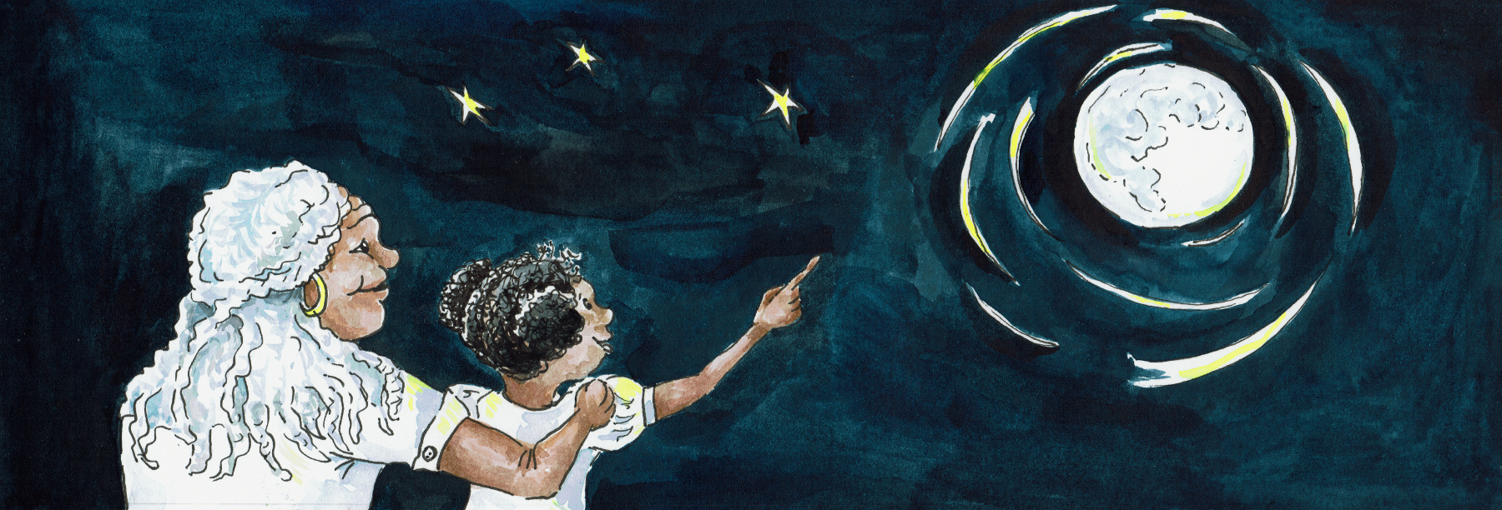
Suggested Age Range: 6 - 7 years; 7 - 8 years; 8 - 9 years; 9 -10 years; adults
UK Curriculum: Key Stage Two (Lower)
Suggested UK Year Group: Year Three
UK Primary Curriculum Link: Rocks
Science Subject: What are Meteors? What are Comets?
Science Questions: What are Meteors and Comets made of?
Suggested Science Activity: Edible Comets, Comet Tails
Children with SEND: Use to boost comprehension of vocabulary
EAL children: Beginners Level
Country of Origin: First Nations of America (Seneca)
Source: The Origin of Stories in Indian Legands of Canada by Ella Elizabeth Clark

Imagine …
That you are in the land of the Prairie, where the tall grass reaches towards the sky, and the grass shines golden in the Sun. And the prairie stretches for mile upon mile across the land we now call America.

And in amongst the Prairie grasslands, there is a circle of tents, called tipis, where the first people lived. And in one of those tents, there lives a family, a woman, a man and a foster-boy. Now this boy, his parents died when he was very young, he can barely remember them. As far as he can remember, he has always lived with the man and the woman.
And though they give him food and shelter in their tent, it never really feels like his home.
Every day, the boy goes out searching for berries and fruit and hunting for deer and rabbit for meat, to bring back to share with his foster family. And this he does day, after day after day.

But …
One cold and windy day he cannot find any food. All the berries have been picked, the fruit has dried and withered and the animals seem to have disappeared. He doesn’t want to go back empty-handed so he continues to search further and further away from his home. And so, when the Sun begins to set, and it grows dark and cold he realises that he has travelled too far to return. Where will he sleep tonight? How can he find shelter from the cold?
And then, he walks into a clearing and in the centre of the clearing, is a standing stone, Grey-black in colour, it feels strangely smooth when he touches it. It is bigger than any stone he has ever seen.The boy sits down and huddles against the stone, using it as shelter from the wind. The stone seems warm and comforting against his back.

And then, he hears a voice …

“Would you like a story?”

He looks around him. But there is no-one there.The voice speaks again.
.
“Would you like a story?”

He can’t believe his ears! The voice is coming from the stone! He can feel the vibrations against his back!

“Yes please!” he says.

And the stone begins. And the stone tells him the story of how Sky-Woman created the Earth as she fell from the sky.

“Is that true?”he asks the stone.

“Oh yes.” says the stone, “For I was there when the world began, falling through space with sky-woman. I am as old as the Sun, as old as the Earth. Far, far, far older then you. I was there, when the stories began”.

“Will you tell me another story?’ asks the boy.

“It is customary, when someone tells you a story, to give them something in return.” says the stone in reply.

“ Oh” said the boy. “I didn’t know. No-one has told me a story before.”

And he looks down at his possessions, at the little he has. A worn-down knife, a hand-me-down coat, with a few old faded beads as decoration on the fringe. He carefully takes the knife and cuts off the beads and places them in a hollow at the bottom of the stone.

“Thank you” says the stone.

And the stone begins another story, about how Coyote and all the animals created the Stars long ago. And when the story is over, the boy curls up against the stone and sleeps.
When he wakes the next day, he rubs his eyes and remembers the stories. Surely they must have been a dream?
But …
When he looks, he sees the beads are gone from his coat and from where he placed them last night. The stone is silent. The boy gets to his feet. But instead of turning back the way he had come, he turns instead to go further into the grasslands furthest from his old home. And so, at sunset, when his stomach is growling with hunger, he finds himself in another clearing, with another circle of tents, and something smelling tempting on the fire. And the people who are sat around the fire, they smile in welcome. He sits with them and shares their food. Once he has finished eating, he wonders: “What can I give them in return?’

And he remembers the stone.

“Would you like a story” he says timidly to these strange but kind people.

They nod in reply, so he begins. He tells them the stories he has heard from the stone. And when the stories are over, someone passes him a blanket and he curls up by the fire and sleeps. And so he stays there and makes a new home for himself.
Every day, he goes back to the stone, to hear a new story, which he tells at might around the fire, to his new people.And then one night, a young girl, that he has seen once or twice around the fire, comes shyly up to him.

”Here” she says “I have made you something to keep your stories in.”

And she hands him a little woven bag. And as he takes it, he smiles back at her, and she smiles back at him. And so of course in time, the two are married and in time they are due a baby. One night, just before the baby is born, the stone says to him.

“You must go. My stories are finished. Now is the time to pass them on”

And from that moment on, he doesn’t have time to go back to the stone. He is so busy looking after his growing family. But at night, every night, he makes time to tell them a story, a story that he has heard from the stone. And so time passes until his children are grown and have children of their own. And he forgets all about the stone. And then one day, one of his grand-children comes to him and says:

“Grand-father, where do the stories come from?”

And so he takes his grandchild by the hand and leads the child to the standing stone. And there in the hollow at the base of the stone, is a tiny fragment of stone. Her picks its up and places it in the small bag that was made for him so long ago. He places the bag around the child’s neck.

“Here, he said, “This is where the stories are from”

And the child keeps the stone and passes the stories on, to her children and her children’s children, until finally the story is passed on to me - and now - to you.

